ZTERM Escape Sequences | A-Shell emulates some of the more common ZTERM ESC sequences, as described below.  Note that most of the features provided by the ZTERM escape sequences are also available in A-Shell/Windows via a Tab(-10,x) sequence or a subroutine. The advantage of the Tab(-10,x) or XCALL method is that the same code will work under A-Shell/Windows and A-Shell/UNIX with ATE on the client. But the advantage of the ZTERM ESC sequences is that they would work on any server platform (i.e. one that you telnet to) provided the client is ZTERM or ATE. But in the latter case, you should test to make sure you aren't running locally on A-Shell/windows, where the ESC sequences would not make much sense.  Many of the ZTERM ESC sequences use a CHR(0) (aka null byte) as a delimiter. However, if for some reason you have difficulty sending null bytes, you can use CHR(128) as an equivalent alternative.  Examples  Execute or print windows file ("shell execute")  ?CHR(27) CHR(12);OP$;FSPEC$;CHR(0);  (OP$ is "O" to "open" or "P" to "print)  INPUT A ! CR for ok, Control-C for error  Execute windows command (aka "win exec")  ?CHR(27);CHR(22);CMD$;CHR(0);  INPUT A ! CR for ok, Control-C for error  Get client ip address  ?CHR(27);CHR(15);  INPUT "",IP'ADDR$  ftp file transfer  ?CHR(27);CHR(1);CHR(127);DIR$;HOSTDIR$;CHR(0); &  HOSTFILE$;CHR(0);PCFILE$;CHR(0);  INPUT A  ATE supports transferring entire directories, in addition to single files, by setting the HOSTFILE$ or filename portion of PCFILE$ to “*”.  Label window  ?CHR(27);CHR(13);TITLE$;CHR(0);  ! sets title for both normal and minimized window  Set window state  ?CHR(27);CHR(25);CMD$ !(CMD$ is M, X, R, or N)  Flash window  ?CHR(27);CHR(16);"1" ! start flashing  ?CHR(27);CHR(16);"0" ! stop flashing  Set ftp login name/password  ?CHR(27);CHR(29);NAME$;CHR(0);PW$;CHR(0);  Serial Passthrough  As of build 946.6 of 26 Novenber 2005, A-Shell/ATE supports ZTERM-type serial passthrough.  Enable passthrough:  ? chr(27); chr(27); chr(3); params$; chr(0);  Disable passthrough:  ? chr(27); chr(27); chr(4);  params$ is of the form:  "<port#>,<baud>,<parity>,<databits>,<stopbits>"  For example:  "1,9600,E,7,2" (COM1, 9600 baud, even parity, 7 bits, 2 stopbits)  When enabled, input from the serial port is merged into the keyboard channel input. Output characters are not normally sent to the serial port. To enable that, send ^X (ASCII 24); send ^T (ASCII 20) to disable. Note that these are the standard AUX PORT ON/OFF commands for the AM6x emulation, but when they are sent while serial passthru is enabled, they have the effect of sending the output to the defined serial port rather than to the printer port.  Extended Example  The following example uses the login name/password stored in the ATE configuration for the ftp name/password. The function to temporarily set a new name/password has not yet been implemented.  GET ZTERM/ATE ID:  ?CHR(27);"?";  xcall GET,BUFFER,0,2,RCVD,1000  IF RCVD<2 goto NOT'ATE'ZTERM  xcall TINKEY,A$ ! extra char?  ?CHR(27);"?";  xcall GET,BUFFER,0,3,RCVD,1000  IF RCVD<2 goto NOT'ATE'ZTERM  xcall TINKEY,A$ ! extra char?  ?CHR(27);"?";  xcall GET,BUFFER,0,2,RCVD,1000  IF RCVD<2 or BUFFER#"ZT" goto NOT'ATE'ZTERM  ?CHR(27);"?";  xcall GET,BUFFER,0,14,RCVD,200  ? "VERSION=";BUFFER  Most AMxxx and WYxxx terminals will respond to ESC ? with 2 bytes indicating the (row and col each offset by 32). However, to be more robust, you should allow for the possibility that the terminal will not respond at all to ESC ?, or that it will give you an extra byte (possibly a trailing CR or a leading ^Y for columns > 96). The above code uses GET.SBR with the timeout option to input up to 2 chars, aborting after 1000 ms. It then uses TINKEY to grab any extra character without waiting. This sequence is repeated 4 times. After the 3rd time, ATE will respond with "ZT" (like ZTERM does). After the 4th time, it will return you "AV" following by the version string. (This is where you can distinguish ATE from ZTERM.)
  ZTERM  Esc Seq | Tab(-10)  Command | XCALL Subroutine | Comment
  27,27,3 |  |  | Enable Serial Passthrough
  27,27,4 |  |  | Disable Serial Passthrough
  27,12 | 24 | MX_SHELLEX | Execute or print windows file ("shell execute")
  27,22 | 23 | HOSTEX | Execute Windows command ("win exec")
  27,15 |  | MX_GETIP | Get client IP address
  27,1,127 | 22 |  | FTP file transfer
  27,13 | 1, 2 | MX_TITLE | Label window
  27, 25 | 27 | MX_SHOW WINDOW | Set window state
  27,16 | 28 |  | Flash window
  27,29 | 29 |  | Set ftp login name/password
Virtual Key Symbolic Names | The Virtual Key Symbolic Names provide a convenient notation for specifying certain control characters to be transmitted into the input buffer in response to a click event on the control; See the CONTROL class cmd parameter, the XTREE xtr'kbdstr, the XTEXT txc'kbdstr, etc.) The names all start with VK_ followed by the name of the key as it relates to the keyboard. The names in the table below can also be altered to indicate the SHIFT or CONTROL version by inserting a “^” and/or lower case “s” after the underscore. For example, “VK_^UP refers to the keystroke Control-Up Arrow, “VK_sDOWN” refers to Shift-Down Arrow, and “VK_^sF2” refers to Control-Shift-F2.  Note that the Virtual Key Symbolic Names can optionally be enclosed in percentage signs ("%"), e.g. "%VK_RIGHT%", which act only as syntax delimiters. Such delimiters would be unnecessary and superfluous in most cases, except in the case where multiple Virtual Key Symbolic Names are being combined. For example, to encode the sequence TAB followed by ENTER, you would need to use the format "%VK_TAB%%VK_ENTER%", since "VK_TABVK_ENTER" would not be properly recognized.  VK_x{r,d}F###  The sequence "VK_x{r,d}F### allows you to generate a wide range of exitcode values in response to various click events for the associated control.  The optional "{r,d}" may be replaced with "", "r", "d", or "rd" (to enable special handling for right click and/or double click events), and "###" is replaced by a numeric string in the range of 1 to 999999 (defining the exitcode value). The actual byte sequence transmitted will be chr(7) + chr(250), followed by the string of digits (corresponding to the ###), and terminated with a period ("."). You can input and interpret such stings yourself using a character-level input routine (such as GET, ACCEPN or the GETKEY function), but many higher level A-Shell routines which wait on operator input events (e.g. INFLD, XTREE, XTEXT, EVENTWAIT, etc.) will do the translation for you automatically, returning the corresponding numeric exitcode value. The following table of examples will help clarify:  Comments  Double-click handling is particularly tricky, since by the time the second click is recognized as being part of a double-click sequence, the first click has already been responded to (by generating the corresponding single-click sequence and exitcode). So in order for this to make sense, the application's response to a double-click has to be a logical extension or continuation of its response to a single click. For example, in a screen full of clickable appointment indicators, the single click event might result in more information being displayed about the appointment, while the double click might launch a dialog to allow editing of the appointment attributes. By contrast, if the single clicked caused the application to change its context, it might then no longer be in a position to properly respond to the double click exitcode.
  Virtual Key | Meaning
  VK_BACK | Backspace
  VK_DECIMAL | Decimal point on numeric keypad
  VK_DELETE | Delete key
  VK_DOWN | Down arrow
  VK_DIV | Forward slash ( "/" ) on the numeric keypad
  VK_END | End key
  VK_ENTER | Enter key (same as VK_RETURN)
  VK_ESCAPE | Escape key
  VK_HOME | Home key
  VK_INSERT | Insert key
  VK_LEFT | Left arrow
  VK_MINUS or VK_SUB | Minus key on the numeric keypad
  VK_NEXT | Next Page or Page Down Key
  VK_PLUS or VK_ADD | Plus key on the numeric keypad
  VK_PRIOR | Prev Page or Page Up Key
  VK_RETURN | Return key (same as VK_ENTER)
  VK_RIGHT | Right arrow
  VK_TAB | Tab key
  VK_UP | Up arrow
  VK_F1 thru VK_F12 | F1 thru F12 keys
  VK_x{r,d}F### | Extended virtual function key codes.
  ^x | Control x where "x" is any character A-Z or [, /, ], ^, _).
  Code String | Click Event | Raw Byte Sequence | Exitcode | Notes
  VK_xF123 | Left Click | chr(7),chr(250),"123." | -123 | Left click exitcodes are negative
   | Right Click | chr(7),chr(250),"123." | -123 | Since no "r" in code string, right click same as left
  VK_xrF42 | Left Click | chr(7),chr(250),"42." | -42 | Note: ### values < 100 not recommended since they may overlap other pre-defined exitcode values
   | Right Click | chr(7),chr(250),"-42." | 42 | "r" present; right click sequence contains "-" but exitcode is positive
   | Left DblClick | chr(7),chr(250),"42.",chr(7),  chr(250),"42." | -42,-42 | "d" not present; double click is same as 2 regular clicks
  VK_xrdF9999 | Left Click | chr(7),chr(250),"9999." | -9999
   | Right Click | chr(7),chr(250),"-9999." | 9999
   | Left DblClick | chr(7),chr(250),"9999.",  chr(7),chr(250),"9999000." | -9999, -9999000 | First click generates normal sequence; second (double) click generates extended version with extra "000" (x1000). See comments.
   | Right DblClick | chr(7),chr(250),"-9999.",  chr(7),chr(250),"-9999000." | 9999, 9999000 | Same as left double click except with positive values.
APEX | Introduction  A-Shell Preview and EXport ("APEX") is a built-in component of A-Shell for Windows and ATE. At the user’s option or under program control, APEX receives a print file and re-directs it into a preview window. That window displays an image of the report and provides the user with various viewing options (zoom, multiple pages, single page, etc.). After previewing the report, the user may then print the report as it was originally intended to be printed (i.e., to the originally-specified printer), print it under user control (different printer, say, or landscape instead of portrait), or discard it. The purpose of the viewer, as with all such print preview functions, is to make sure that you are printing what you think you are printing—and to save time, energy, money and paper in the process. In some cases, viewing the report may eliminate the need for printing entirely.  APEX offers a variety of controls and options to facilitate viewing the report. Most of these items, and how to use them, are fairly obvious.  APEX also includes a valuable "Export to Excel" function, which is initiated by a button on the toolbar.  Following are some screen shots illustrating various aspects of APEX.  Title Bar and Tool Bar  The APEX title bar displays information about the report: original filename ("tstz" in this example), the first (-1) printing this session, temporary extension (.APF for "A-Shell print file"), the number of pages in the report, and Windows printer for which this report is intended, and the printer properties being used for printing. The toolbar provides options (in order from left) to set zoom percentage (10% to 999%); zoom in; zoom out; single page; multi-page grid (drop-down menu); page number / back / forward; print setup; print; help; close; print per application; find text (search); open another report; APEX preferences; export to Excel; export preferences.  Multi-Page Grid  Clicking on the multi-page grid option (see toolbar above) offers choices for the layout of multiple pages. You can (barely) see the grid choices below near the top left. The full screen shows the report in the 4 (across) by 2 (down) grid.  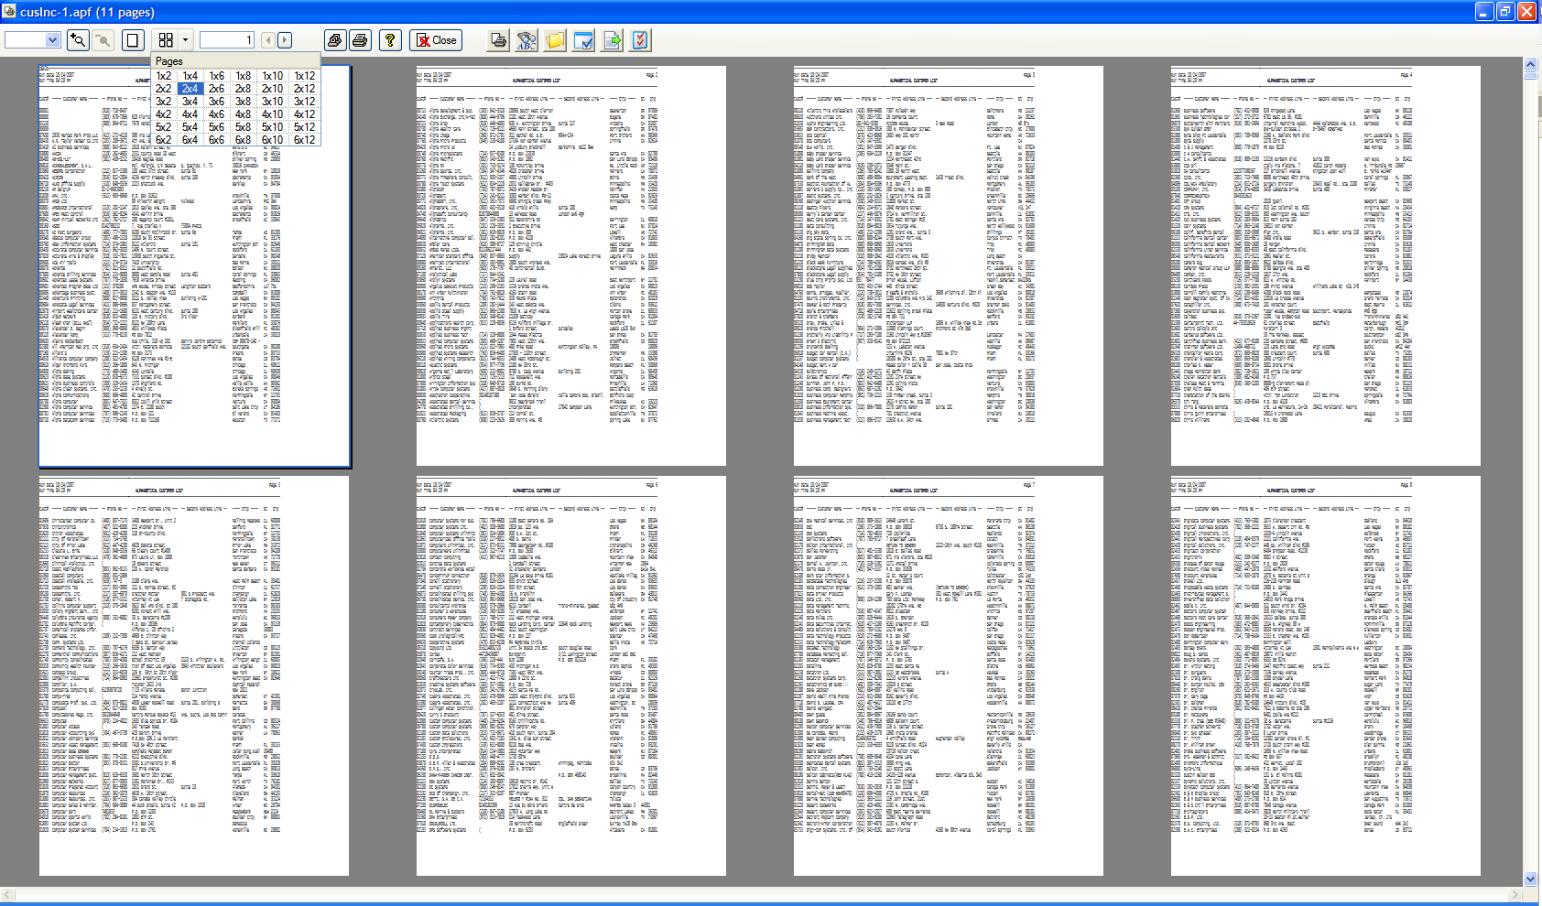  Find Text (Search)  Clicking the find text tool and entering a word into the "Find" dialog box ("exitcode" in this case) causes all the occurrences of "exitcode" on the current (first, in this case) page to be highlighted. Clicking "Find Next" displays the highlighted words on the next applicable page, etc.  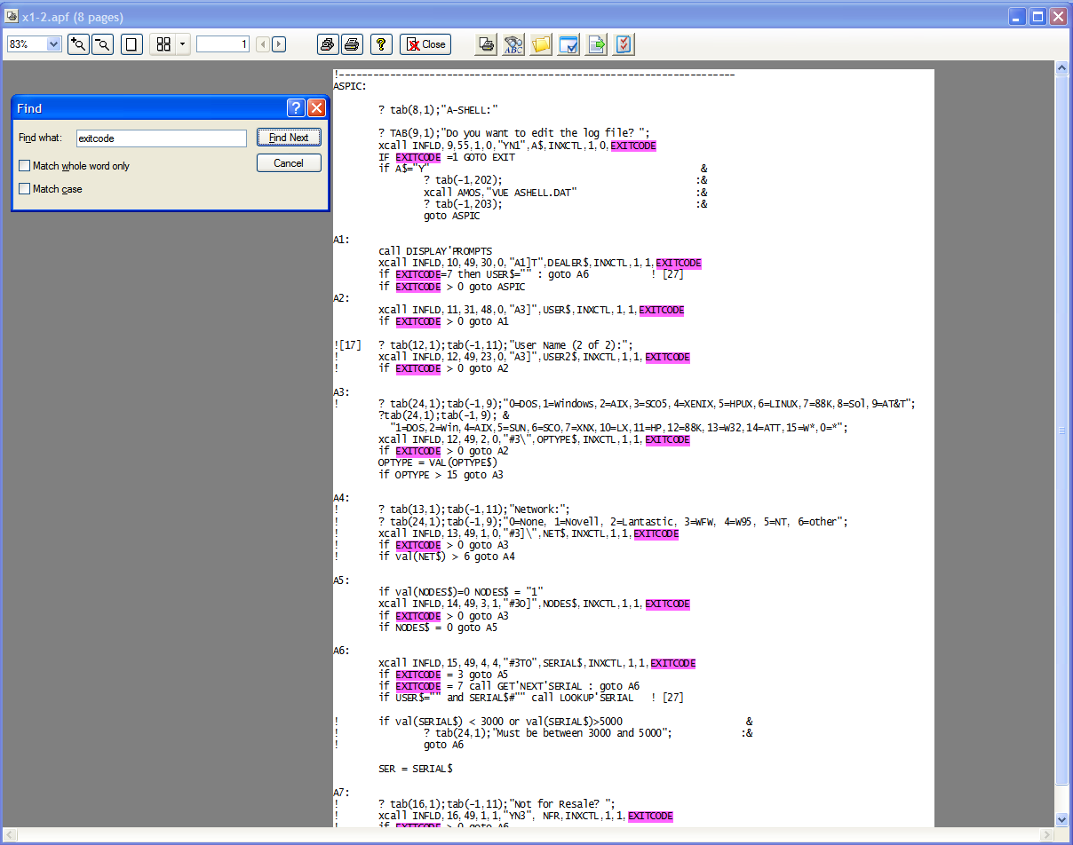  Licensing  The programs and files needed by APEX are automatically installed on the PC with the underlying software (A-Shell for Windows or ATE). Starting from the date it is installed, APEX will work in unrestricted mode for approximately 30 days. After that free-trial period, APEX reverts to demo mode, which means that it will work so you can see its functionality, but with qualifications. When operating in demo mode, APEX will display an annoying message saying that it is in demo mode.  To enable full APEX operation on your PC, you will need to obtain an APEX software license from either your application provider/dealer or from MicroSabio.  Preferences  Several things about how the preview function behaves are under user control, and these things are set on the Preferences dialog. This dialog is accessible from both the menu bar in A-Shell/ATE (Settings | Preview Preferences) and from the Preferences button on the preview toolbar. The following screen shot, while not necessarily identical to the one shown in your version of the program, illustrates some of the user-controlled options.  Preferences toolbar button:  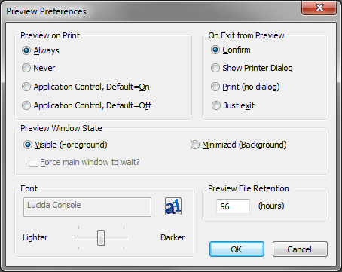  Preview on Print  Normal report printing consists of a report being created by a program, and then being sent to the PC for printing. The "Preview On Print" option allows you, the user, to control the circumstances under which those reports from the host, received for printing, are instead displayed on your screen. The "Always" and "Never" options should be fairly clear. The two "Application Control" options allow you to let the program that created the report determine whether the report is previewed--and gives you the option to say what happens when the report program doesn't specify anything.  There is no right or wrong, or best or worst, setting for this option. It is strictly determined by (a) your needs and objectives, and (b) those of your work environment.  The default value for this setting is "Application Control, Default=Off", which means that (a) APEX is expecting to receive a launch or don't launch command from the program that generated the report, and (b) if it does not get such a command, it will NOT launch.  On Exit from Preview  What do you want to happen when you exit the preview window (which, by the way, you can do by clicking on the "X" in the top right corner of the preview window, or by hitting the Escape key)? As you make your choice, keep in mind that all reports viewed with APEX are saved to disk; you can come back and view them again later if you wish.  Preview Window State  It is not possible for the program that launched the preview, or the programmer who wrote the program, to know how the user wants to deal with the preview: display the preview windows right now, or continue working and view the report later? The Preview Window State allows the user to set her preference for what happens when a report is sent to the preview window. "Visible (Foreground)" means that the preview window is shown right now. "Minimized (Background)" means that the preview window is created right now but then minimized; it appears in the task bar, which you need to click in order to view the report.  Preview File Retention  When a file is viewed using APEX, it is possible that the user may want to view this file again later. So as soon as a report is viewed, a copy of it is written to a file in the APEX folder. If the original file name being viewed is "report.xxx," then the file that is written into the APEX folder is called "report.apf" (apf = A-Shell Print File). These files remain in the APEX folder, and can be opened by the Open another report file button on the toolbar.  How long do they remain in the APEX folder? This is controlled by a setting on the Preferences called "Preview File Retention (hours)." The default value is 96 hours, 4 days, but you can set it to whatever you wish.  From an environmental perspective, the fact that you can view the report again later should make it easier to forego actual printing of every document (after previewing), merely out of fear that you might need it reference it in a few hours or days. The default setting of 96 insures that your disk won't get clogged up with more than four days worth of report files.  Keystrokes and Mouse Clicks  Operations  Zoom Percentage and Zoom In/Out  The Zoom Percentage control shows various steps of zoom. When you use the magnifying glass buttons to zoom in or zoom out, the steps by which you zoom are those shown in the zoom percentage control. You may manually set (by typing it in) the zoom percentage to any value between 10 and 1000. Note that when you are selecting a value for the zoom percentage control, and it has the focus, using the PageUp and Down key, as well as the up and down arrows, apply to the zoom percentage and not to the report being displayed. In other words, you can cycle through the zoom percentages by using those directional keys.  Find Text  This button on the toolbar will be grayed out (inactive) if the report being previewed does not contain any text—i.e., is all images and/or graphics. To initiate a text search, click on this button and enter the text to be found in the resulting dialog box.  Export to Excel  APEX includes an Export to Excel function which is initiated via a button of that name on the toolbar. There is also a button for setting the export preferences.  Print As Application Intended  This is rather an odd function to see in a Windows program, so a bit of explanation is in order.  Reports that are generated by A-Shell programs frequently are sent—by the report program—directly to a PC printer. In addition to the report, those print instructions include information for the printer, such as the name of the printer, number of copies, etc. However, APEX intercepts the report and (a) stops it from going directly to the printer, and (b) allows the user to now print the report using different parameters than the report program specified. Which is fine, and of course the user can print as he/she wishes.  But she might decide what she really wants, after looking at the report, is for it to be printed how the report program originally intended. Unfortunately she doesn't know what the report program intended; perhaps it was going to print six copies on a network printer called "Laser45."  By using this oddly-named button and function, the user can make sure that the report is handled and/or processed and/or printed as the original instructions intended.  If you do not need this function, just use the regular print operation.  Open another report file  See Preview File Retention for information on what files may be opened and how they got here.  When you click this button, you will see a standard Windows file open dialog. Unfortunately, the list of file names that you see is probably not enough information to figure out what report it is you want to see. On the file open toolbar, you should see an icon near the top of the dialog box called Views, and one of its options is "details." If you click on the details icon, you should be able to see a little more information about the files. You may click on the column headers to sort by those columns in any effort to fine the report you're looking for. Unfortunately, not much information is available to you here, so you'll just have to open as many reports as it takes to find the one you're after.  Printer Control  Beginning with A-Shell 6.0.1242, it is possible to change the printer for which the document is being formated without actually printing the document. From the Print Dialog, select a different printer, click Apply, then click Cancel; the displayed output will then match the newly-selected printer.  Other Topics  Custom Extensions  You can add your own extensions to APEX, which are accessed as buttons on the toolbar and which call your own BASIC code, by defining them in the APEX configuration file, ASHCFG:APEX.CFG. The configuration file, if present, is scanned for commands of the following form:  BUTTON=prog, iconspec, tooltip {,msgno, inifile}  prog  indicates the subroutine which implements the extension. In theory it wouldn't have to be an SBX, but currently that is the only format supported, so prog must be in the form of "SBX:name", e.g. "SBX:PRTXLS". The corresponding subroutine (e.g. PRTXLS.SBX) must be in the BAS: directory (e.g. c:\ate\dsk0\007006\prtxls.sbx). The subroutine should be written according to the same interface specifications used by the printer initialization command line, COMMAND=SBX:... (see A-Shell Setup Guide).  iconspec  specifies the icon to display in the button that will be added to the toolbar. Supports the same syntax as for AUI_CONTROL icon buttons (see the A-Shell XCALL Reference).  tooltip  is a short tooltip to display when the mouse hovers over the button.  msgno (optional)  may specify a message number in the file <inifile.lng>, where lng is the current language extension, e.g. USA, to supply the tooltip text. If present, it overrides the tooltip parameter above.  inifile (optional)  may specify an initialization file used by the extension, although the details of how is is used are up to the custom code in prog.  The file may also contain any number of comment lines, each beginning with a semicolon in the first position. Here's , for example:  ;APEX customization  ;BUTTON=prog,icon,tip{,msgno,ini}  ;If msgno>0, is expected to be msg 002,### in inifile.lng  BUTTON=SBX:PRTXLS,ashico1::document_out,Export to Excel,38,BAS:PRTXLS.INI  BUTTON=SBX:PXLCFG,ashico1::preferences,Configuration Options For Export,0,BAS:PRTXLS.INI  There are no particular limitations on what the subroutine (prog) may do, other than that it cannot delete or replace the file being previewed, and must eventually return so that APEX can resume control.  Debugging  In case of a problem launching the preview from ATE, use the debug message window to help clarify what is happening. Call up the A-Shell GUI Control Operations dialog with control+shift+double-right-click, then select Show Debug Dialog. When the debugging/trace window comes up, repeat the print attempt. It will log the command string that is actually being used, which might then be helpful to test independently, such as from Start..Run, or at least useful in identifying the problem.  Settings  In ATE, changes to Preferences are immediately stored with the connection profile in the Windows Registry. This means that they are both implemented immediately, and saved for future use; all subsequent operations of the preview window, whether in this session or new sessions, will reflect the latest settings.  In A-Shell/Windows, changes to Preferences are part of the overall A-Shell settings set which, along with the other options on the various Settings menu dialogs, are stored in the A-Shell settings (.ash) file. However, as with all other settings, changes made in the dialogs are not automatically written to the file. Thus, they only affect the current session. To make them permanent, you must save them via the File | Save option.  Files and Folders  When you call up the Preferences menu, the actual words you see are taken from the file SYS:SBRMSG.USA. If you see odd codes in place of intelligible options, then your SBRMSG file is not being found.  Any temporary work files required by APEX are also created in the APEX folder.  The default location of the APEX folder is c:\apex, and this folder will be created the first time it is needed. If you don't like this folder and/or want it to be placed somewhere else, you may create an environment variable called "APEX" and point it wherever you wish.  Most of the print preview and display-related aspects of APEX are performed by a program module called "SftPrintPreview_###.dll" where "###" is platform and version information. This file lives in the main A-Shell or ATE folder on your PC.  Most of the export-to-Excel functionality is contained in the subroutine "prtxls.sbr." This file is found in DSK0:[7,6] of the A-Shell or ATE file system.  PRTXLS.INI Export Init File  Various operations and options in the export-to-Excel process are controlled by settings in the export initialization file, PRTXLS.INI. If this file is missing or an individual lines/statement is missing, APEX will use the value shown as "Default" in the table below. The init file is normally stored in the [7,6] directory or equivalent, although when PRTXLS.SBX is invoked from the COMMAND statement of a printer init file, the init file specification may be passed as an argument (e.g. COMMAND=SBX:PRTXLS,dsk7:xls123.ini[40,30]).  Note that each of the statements below must reside within the section indicated. Within a section, the order or presence/absence of a given statement is not relevant. The section names are in upper case, are enclosed in square brackets, and are preceded by a blank line. See the sample init file section.  As with many init files, lines beginning with semi-colons are comments and are ignored by the file processor. Comments can only occur on their own lines--i.e., cannot be appended to the ends of command lines.  Sample Init File  ;PRTXLS.INI - Config file for PRTXLS.SBX  [DATA]  IncludeTotals=1  [REMNANTS]  IncludeBlankLines=1  IncludeDupLines=1  SortBy=1  [ORIG]  ;BGcolor options: silver,white,red,lime,blue,yellow,magenta,cyan,brown,green,navy,purple,gray,orange  BGcolor=silver  [POST]  AppendSeqno=1  SaveToDir=c:\vm\miame\dsk0\150502  SendToPC=1  Launch=1  ; RemoteServer spec is IP address, colon, port  RemoteServer=11.111.111.111:222  IgnoreLocalServer=1  [MISC];ServerErrorURL=http://  Troubleshooting Export to Excel  If the Export to Excel function does not work, either at all or properly, perhaps understanding the sequence of events will help you find and fix the problem.  Requirements: Perl has been installed on the host computer or PC, as appropriate. The report has been displayed with the A-Shell print preview function.  • The Export to Excel button is enabled if and only if the A-Shell subroutine PRTXLS.SBX is present and available. It should be located in the directory [7.6]. If the Export to Excel button is inactive (grayed out), it is because this file is missing.  • ATE only: the preview session of ATE (which itself is a second ATE session) launches another session of ATE to handle the export process. This job runs in the background and remains hidden except for the progress window.  • PRTXLS.SBR creates a temporary working/debugging file called <sourcefilename>.XLX.  • PRTXLS.SBR generates Perl script with the name <sourcefile>.PL.  • PRTXLX.SBR executes PERL script. If the process breaks at this point, it is probably because the required Perl function "\spreadsheet\WriteExcel.pm" is not being found. This in turn may be because Perl is not installed, or because "\spreadsheet\WriteExcel.pm" is in the wrong location.  • The Perl script runs and creates a spreadsheet file called <sourcefile>.XLS, which is placed in the xxx folder.  • The temporary files (.XLX and .PL) are erased, and extra ATE session is shut down,  To assist in troubleshooting, you may want to use the debug function. To turn it on, check the "Debug" option on ATE's Connection Properties | Printer | General Options. If you are using A-Shell rather than ATE, get to the prompt and enter SET DEBUG.
  Key or Mouse | Action
   | Multi-page Mode
  Home | Positions to the first group of pages, starting at the first page. The first page becomes the current page.
  End | Positions to the last group of pages, ending at the last page. The first page of the displayed pages becomes the current page.
  Ctrl+Home | Same as the Home key.
  Ctrl+End | Same as the End key.
  Left Arrow | Moves to the previous page. The displayed group of pages is adjusted if necessary.
  Right Arrow | Advances to the next page. The displayed group of pages is adjusted if necessary.
  Up Arrow | Moves the first page of the displayed group of pages to the previous page (or sheet in duplex mode). The current page is adjusted if necessary.
  Down Arrow | Advances the first page of the displayed group of pages to the next page (or sheet in duplex mode). The current page is adjusted if necessary.
  PgUp | Displays the previous group of pages. The current page is adjusted if necessary.
  PgDn | Displays the next group of pages. The current page is adjusted if necessary.
  Plus on NP | Zoom in. ("NP" refers to the numeric keypad.)
  Left Click | Display page clicked in single-page view at scaling of last single-page view.
  1 (numeric) | Switches from multi-page mode to single page mode.
   | Single Page Mode
  Home | Positions to the top of the current page.
  End | Positions to the end of the current page.
  Ctrl+Home | Positions to the top of the first page.
  Ctrl+End | Positions to the end of the last page.
  Left Arrow | Horizontally scrolls left on the current page.
  Right Arrow | Horizontally scrolls right on the current page.
  Up Arrow | Vertically scrolls up on the current page.
  Down Arrow | Vertically scrolls down on the current page.
  PgUp | Vertically scrolls up on the current page. At the top of the current page, move to the bottom of the previous page.
  PgDn | Vertically scrolls down on the current page. At the end of the current page, advance to the top of the next page.
  Plus (keypad) | Zooms in , big jump; same as "plus zoom" button.
  Minus (keypad) | Zooms out, big jump; same as "minus zoom" button.
  Left click | Zooms in , big jump; same as "plus zoom" button.
  Right click | Zooms out, big jump; same as "minus zoom" button.
  Plus | Zooms in, little jump. (Note: does not require Shift key)
  Minus | Zooms out, little jump. (Note: does not require Shift key)
  Ctrl+Plus | Zooms in, tiny jump.
  Ctrl+Minus | Zooms out, tiny jump.
  Escape | Close
  2 (numeric) | Switches from single page mode to multi-page mode.
   | Both Modes
  Escape | Close
  Ctrl+P | Print
  Alt+Ctrl+P | Toggles between main window (A-Shell or ATE) and Preview.
  Ctrl+Enter | Toggles between multi-page and single page modes.
  Ctrl+Alt+ | Toggles between maximized and normal windows.
  Ctrl+G | Go to page number control.
  Ctrl+Z | Go to zoom control.
  F1 | Help
  F3 | Find
  Statement | Section | Values | Default | Description
  IncludeTotals | DATA | 0,1 | 0 | If set, lines which look like totals or subtotals are treated as data lines.
  IncludeBlankLines | REMNANTS | 0,1 | 0 | If set, blank lines are included in Remnants worksheet.
  IncludeDupLines | REMNANTS | 0,1 | 1 | If set, duplicate lines are included in Remnants worksheet. (Otherwise only one line per set of duplicates is included.) For example, if set, the Remnants page may have many identical lines containing column headers.)
  SortBy | REMNANTS | 0,1 | 0 | If set, Remnants lines are sorted by their contents.
  BGcolor | ORIG | See sample init file | Silver | Background color of "Original" worksheet.
  AppendSeqNo | POST | 0,1 | 1 | If set, a sequence number is appended to the XLS filename to make it unique.
  SaveToDir | POST | Path specification |  | Directory where the XLS file is saved.
  SendToPC | POST | 0,1 | 1 | (UNIX only) If set, causes the exported XLS file to be transferred to the PC using ATE/ZTERM FTP protocol.
  Launch | POST | 0,1 | 1 | If set, the spreadsheet program (typically Excel) is launched to view the spreadsheet.
  RemoteServer | POST | IP address: port | n/a | Specifies the location of a service to generate the XLS file. (Local generation requires that Perl be available and the WriteExcel add-on library be installed.)
  IgnoreLocalServer | POST | 0,1 | 0 | Set to force use of RemoteServer even if local generation is available.
  ServerErrorURL | MISC | URL |  | URL of page to display when an error related to the RemoteServer occurs.
Trace | The following table shows the options used with the TRACE function. The “Used In” column specifies if the option applies to the TRACE system parameter (“INI”) or to the SET TRACE command (“SET”).
  Option | Used In | Description
  AMOS | INI, SET | Logs information related to the use of XCALL AMOS and operations that involve the launching of another ashell session.
  AMSORT | INI, SET | Displays information (in a pop-up window) during sorting operations, showing the type of sort, current phase, memory usage, etc. If sorts are talking a long time, this can be very useful for determining what is happening, and how much memory you might need to improve the performance. (For very large sorts, we also offer an add-on “world class” sort module that is much faster and more flexible, but requires a small license fee; contact us for details.)
  ATE | INI, SET | Logs details of the GUI commands and responses sent between a server and an ATE client. Note that this command might make sense to activate on both the server and the client, as they have different perspectives. This will result in two log files, one on the server and on the ATE client.and responses.
  BASERR | INI, SET | Logs all Basic errors, indicating if they were trapped or not, along with other details typically lost in the translation between the user experiencing the error and the programming investigating it. Highly recommended for nearly all installations.
  DEBUG | SET only | This is a catch-all for logging all kinds of information. It should only be used in focused circumstances, since the amount of tracing data quickly becomes overwhelming. May also be activated via the –trace switch on the A-Shell command line.
  FOPENS | INI, SET | Logs information about file opens (both programs and data). Under Windows, this also includes how many microseconds it takes to open the file, which can sometimes be useful in identifying bottlenecks due to network issues.
  GDIPRT | INI, SET | (Windows only) Logs and/or displays information about processing of GDI printing directives.
  GUI | INI, SET | (Windows only) Logs details about various low-level GUI operations. It is quite verbose.
  INOUT | INI only | Writes debugging information to ashlog.log as each new instance of A-Shell is opened or closed, indicating the number of jobs running at that point. Highly recommended for virtually all installations. .
  ISAM | INI, SET | Logs ISAM operations.
  JOBS | INI only | Logs details relating to the job table operations (quite verbose).
  KBD | INI, SET | Logs keyboard operations (quite verbose).
  LOCKS | INI, SET | Displays debugging information on the bottom status of the window related to record locking operations. In particular, it provides a sense of how many retries or how long the job is waiting for access to a record. In the case of FLOCK, it will also display all of the relevant locking parameters whenever the XCALL is forced to wait and whenever it exits with a non-zero error code.
  LP | INI, SET | (Possible in INI context, but not recommended.) Displays on the screen details about printing, including processing of any EZSPL configuration file, plus the printer init commands, plus the actual communication or initialization operations with the printer itself. Extremely useful for debugging printing problems. (SET TRACE LP ON, then using PRINT to print a dummy file, like ERSATZ.INI).
  MALLOC | INI,SET | Log details of all memory allocations.
  QOP | INI | Logs details relating to queue block operations.
  RW | INI, SET | Log all random/isam file reads and writes, INPUT and PRINT file opersations, SERCH reads.
  SIGHUP | INI, SET | Log receipt of SIGHUP (hangup) and SIGTERM (kill) signals, along with information indicating how the signal was responded to, whether the program and ashell session were shut down, etc. We recommend you set this switch permanently in the miame.ini file (TRACE=SIGHUP) since they should be relatively rare and frequently either worth investigating directly, or they provide an explanation for something else you are investigating.
  SIGNAL | INI, SET | (UNIX only) Same as the SIGHUP option, but also displays on the screen the name of any trapped signal received by the process. See Trapping Disconnects and Kills in the A-Shell Development Guide for more information relating to handling of incoming signals.
  SOCKS | INI, SET | Logs details about TCP (socket) operations.
  SQL | INI, SET | Logs information about SQL operations.
  SYSERR | INI, SET | Display (in a pop-up window on screen) details about all errors. This is sometimes useful for see the system error details corresponding to a particular A-Shell error, but can also be annoying since it presents the appearance of a serious error having occurred, sometimes in situations that weren’t really very serious at all.
  USRMEM | INI, SET | Log details about “user memory” operations – i.e. loading of programs, subroutines, function key translation files, etc.
  XCALL | INI, SET | Logs most subroutine calls. Certain extremely common routines, like MIAMEX, are not logged, unless the XDEBUG trace is also activated.
  XDEBUG | INI only | Increases the verbosity of several other traces.
  XTREE | INI only | Logs XTREE operations.
ASHINC | The ASHINC: ersatz directory (normally DSK0:[907,16]) contains the ++include files supplied with A-Shell. Although these files are not mandatory for programming, they help minimize the confusion and potential for error inherent in the complicated data structures and thousands of opcodes, options and flags which are typically employed in XCALL and function parameters. By referencing the relevant ++include files in your programs, you gain instant access to standardized MAPs, structures, and symbols that make your programs easier to read, write, and share with others, as well as maximizing the utility of our documentation, which is heavily indexed and/or searchable on these same symbols and map/structure names.  The ASHINC: directory contains the following kinds of files, identified by their extension:  Other than a small version signature (about 40 bytes), DEF and SDF files do not increase the size of the resulting RUN programs. They merely expand the "vocabulary" of the compiler. They do, however, require the COMPIL /X:2 switch. When there is both an SDF and MAP file, the SDF is generally preferable, as it allows multiple copies of the structures to be declared, using your own prefixes. The MAP files represent the older approach used before defined structures were introduced.  Here is an overview of the most commonly used files. New ones are added periodically, typically with names matching the XCALL or subsystem to which they refer.
  Extension | Description
  DEF | Symbol definitions (e.g. define MBF_STATIC = &h00040000)
  MAP | MAP statements
  SDF | Structure definitions
  BSI | Actual code (possibly including MAP statements, function/procedure definitions, etc.)
  Filename | Description
  ashell.bsi | Code commonly used in LIT programs (e.g. command line processing)
  ashell.def | A core set of symbols used in nearly every A-Shell program, especially those containing MIAMEX calls
  ashell.sdf | Structure definitions associated with common MIAMEX calls
  csidl.def | CSIDL_xxxx symbol definitions (used by MX_BROWSEFOLDER and MX_GETSHELLPATH)
  evtmsg.def | Symbols used with XCALL EVTMSG
  gtlang.map | Mapped structure used by XCALL GTLANG (get language definition)
  hook.def | Symbols used by the file hook mechanism (see MX_FILEHOOK)
  http.def | Symbols used by XCALL HTTP
  isam.def | Symbols related to ISAM
  jobtbl.def | Symbols related to fields in the job table
  jobtbl.map | Mapped structure representing JOBTBL.SYS records - see MX_READJCB
  msboxx.def | Symbols related to XCALL MSBOXX
  regex.def | Symbols related to regular expressions
  sql.def | Symbols related to XCALL SQL
  trmchr.map | Mapped structure used by XCALL TRMCHR (terminal characteristics)
  xcall.bsi | Startup code useful in writing custom SBX routines
  xtext.def | Symbols related to XCALL XTEXT
  xtext.sdf | Structure definitions for XCALL XTEXT parameters
  xtree.def | Symbols related to XCALL XTREE
  xtree.map | Mapped structures compatible with XCALL XTREE
  xtree.sdf | Structure definitions for XCALL XTREE parameters

